Project Journal

Week 7
Following the previous 2 weeks’ project pitches, I begun working on my videogame.
I created two avatars, the character and the fire that the user has to dispel.
I also coded an initial interaction between the character and the fire, however my progress halted as I ran into a roadblock.
- When the user navigates to the fire, they are prompted to press “B” to add water to the fire and make it disappear. I would like a water avatar to be placed over the top of the fire, however I am struggling to action this
Week 8
This week I received strong feedback from my tutor about my project pitch. He suggested I include more references, specifically ones related to the semesters’ coursework and required readings. Strengths of my pitch was that it was great, with strong insight and personal link, as well as a strong relevance between my chosen coding environment and the proposed project.
This week I am going to go back through each weeks’ coursework and refresh the information I’ve learnt about coding. This will ensure I can draw information from the readings and link my project to what I’ve learnt.
- I’m using AI in Microsoft MakeCode to explain problems that prevents actions from occurring.
I have been going between Blocks and Python Code in creating my game. However, the tutor told me I should just be using one or the other, not both simultaneously. I have chosen to continue with Blocks as I continue to struggle with code. I do however, upon completing a section of code in the Blocks section, go back to Python code and read how it is laid out.
Stu-Vac
During Stu-Vac I begun working on my 1,000 word personal critical reflection. I began by previous understanding of code and previous experiences of using code and data. I also spoke about my interaction with weekly readings and class activities and how these academic sources helped build my knowledge to further my prototype.
I also worked more on my video game. I am currently trying to figure out how to make the fire sprite disappear when water is placed on top of it.
Week 9
I received verbal feedback from a few peers in class. They stated:
- “I’d play that”
- “That’s so cool”
Working more on my game, I had to introduce repetitive coding.
Week 10
I have completed the introductory code, and the code for the remainder of the game is quite repetitive. If I have time prior to submitting, I will have the code repeat until the 60 seconds is over, however as the code is repetitive and I don’t feel I’m learning anything new.
This week I am aiming to add a counter to the game, so whenever the user destroys a fire sprite, the counter increases by 1 point. By the end of the 60 seconds, if you destroyed 10 fires, your counter would read 10.
Week 11
This week we created a GitHub account and learnt how to insert all our project materials into this site.
An issue I ran into this week is that when I go to download my video game, Microsoft MakeCode provides many download options to suit different program types, devices and consoles.
I had to ask the tutor Andrew to provide a download type suggestion. He directed me to a video tutorial he created in Canvas additional resources. In this video tutorial by Andrew,

Week 12
This week I had a peer provide a Final Peer Review, the peer who reviewed my prototype was Sienna. Sienna gave great feedback, which I will discuss in my reflection.
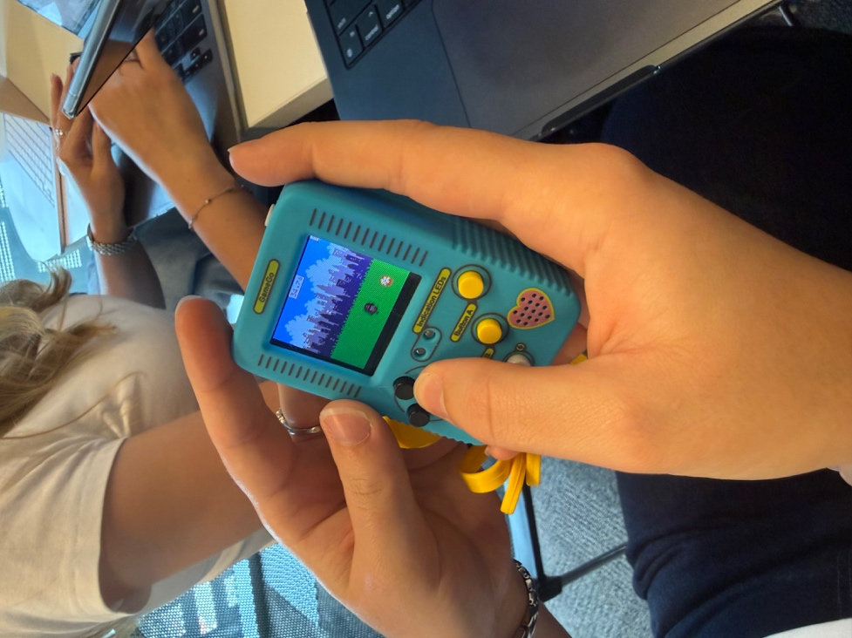
The tutor brought a TinkerGen Game Go to class, and those with video game prototypes were able to play their game with a physical device, rather than playing the game on their computer. I had a peer take some videos and picture content of me using this physical device, which I will include and discuss in my reflection.

